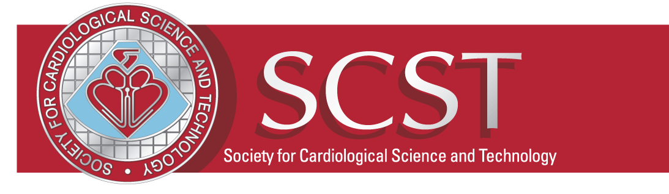
2022 SCST Excellence Awards
Nomination Form
SCST invites you to nominate colleagues that you think should be recognised within our profession.
Rising Star Award
A staff member or colleague who has recently qualified or is undertaking an Apprenticeship, PTP or STP qualification and shows great insight and innovation in the role. The actions of this colleague will likely offer better diagnostic service within the workforce and/or their approach to their job will allow for better patient care.
Innovators Prize for Transformation
A staff member or colleague who has proactively created transformational change in a service or department. This change has led to either financial savings, time savings or resulted in a better diagnostic provision allowing better patient flow.
Patient Care Award of Excellence
A staff member or colleague who proactively offers exceptional patient care on a daily. Going above and beyond in a pursuit that offers excellent patient care.
Unsung Hero Award
A staff member or colleague who has made a real difference to their team department or patients. A colleague who is a proactive team member and completes their role in the betterment of their department without requesting acknowledgement or dispensation for what they do on a daily basis.
The Dave Richley Award for Outstanding Education
A staff member, colleague(s) or team who have proactively pushed education forward in their trust or the wider department team. Raising standards and the profile of the Cardiac workforce on the whole.

Who would you like to nominate?
Nominee full name
Nominees Role
Nominee department
Nominee Trust
Nominee email address
Is the Nominee an SCST member? | YES/NO
About you
Your name
Your Role
Your department
Your Trust
Your email address
Your SCST membership number
Which category would you like to nominate this team or person? ✔
Rising Star Award
Innovation Prize for Transformation
Patient Care Award of Excellence
Unsung Hero Award
The Dave Richley Award for Outstanding Education

The reason for your nomination
In no more than 500 words, please outline why you are nominating the above person. Please provide as much information and evidence as possible from the last 12 months considering the award description.
Would you like this nomination to remain anonymous? (delete as applicable)
Yes, please don’t show my name
No, I am happy for my name to disclosed to the nominee
What Happens next?
You will receive confirmation of receipt of your nomination. Your nominee will be informed of their nomination unless you have stated otherwise. Nominations will be discussed and a winner chosen. The successful nominee will be informed and the award will be presented at the SCST National Update Meeting on the 04/02/2022 (format to be confirmed).

How we will we use your nomination?
The SCST Council may use your nominations in several ways including printed information, displays, exhibitions, on our website and on social media. Occasionally we may contact you with opportunities to submit your nomination for other award schemes.
By submitting this form, you agree that your nomination can be used for these purposes by the SCST We reserve the right to continue to use the nomination until you advise us otherwise.
I give my consent as indicated above

Signed:
Date:
SUBMIT VIA EMAIL TO: comms@scst.org.uk
CLOSING DATE: Sunday, 16th January 2022

